Does Discounting Actually Hurt Profit?
A Hypothesis Testing Report on Retail Sales Data
Week 3 Task – Statistical Analysis and Hypothesis Testing in Python
Yuva Intern / NSDC Data Analytics Program
Python libraries used: Pandas, NumPy, SciPy, Matplotlib, Seaborn
August 2026

1. Introduction and Hypothesis
For this task I reused the retail sales dataset I built for the Week 2 visualization assignment (9,000 order records across 5 regions, 3 product categories, and 3 customer segments, from Jan 2023 to Dec 2024). In that report I noticed on the discount-vs-profit chart that heavily discounted orders looked like they were losing money, but I never actually tested that statistically - it was just eyeballed from a scatter plot. So this week I wanted to go back and properly test it, along with two other questions I was curious about.
I picked three separate hypotheses so I could practice three different tests, as required by the task:
- H1 (t-test): Discounted orders have a lower average profit margin than non-discounted orders.
- H2 (chi-square): A customer's segment (Consumer / Corporate / Home Office) is related to which product category they buy.
- H3 (ANOVA): Average order value (Sales) is not the same across all five regions.
For each one I set a null hypothesis (no difference / no relationship) and an alternative hypothesis, ran the appropriate test in Python, and checked the result against a significance level of α = 0.05.

2. Data and Methodology

2.1 Dataset
Same dataset as last week - retail_sales_synthetic.csv. Relevant columns for this analysis: Region, Category, Segment, Sales, Profit, Discount, and ProfitMargin (Profit divided by Sales). I added one derived column, Discounted, which is just "Discounted" if Discount > 0 and "No Discount" if Discount = 0, so I could split the data into two clean groups for the t-test.

2.2 Why these tests
- Independent samples t-test - because I'm comparing the mean of a continuous variable (profit margin) between two independent groups (discounted vs not).
- Chi-square test of independence - because both Segment and Category are categorical variables, so I can't use a t-test or ANOVA here. Chi-square checks whether the observed counts in a segment x category table differ from what you'd expect if the two variables were unrelated.
- One-way ANOVA - because Region has 5 groups (not just 2), so a t-test doesn't apply directly. ANOVA checks whether at least one region's mean Sales is different from the others.

2.3 Tools
All tests were run using scipy.stats (ttest_ind, chi2_contingency, f_oneway). I also computed the ANOVA sum-of-squares table manually with pandas/numpy to double check scipy's F value and to actually understand what's going on under the hood instead of just calling a function. Charts were made with Matplotlib and Seaborn.

3. Test 1 – Does Discounting Lower Profit Margin?

3.1 Hypotheses
H0: mean profit margin is the same for discounted and non-discounted orders.
H1: mean profit margin for discounted orders is lower than for non-discounted orders (one-tailed).

3.2 Code
disc = df.loc[df.Discounted == "Discounted", "ProfitMargin"]
nodisc = df.loc[df.Discounted == "No Discount", "ProfitMargin"]

t_stat, p_two = stats.ttest_ind(disc, nodisc, equal_var=False)
mean_diff = disc.mean() - nodisc.mean()
se_diff = np.sqrt(disc.var(ddof=1)/len(disc) + nodisc.var(ddof=1)/len(nodisc))
ci_low, ci_high = mean_diff - 1.96*se_diff, mean_diff + 1.96*se_diff

3.3 Results
Group | n | Mean margin | Std dev
Discounted | 4,547 | -0.012 | 0.193
No discount | 4,453 | 0.302 | 0.085

Welch's t-test (unequal variances, since the discounted group is clearly more spread out): t = -100.45, p < 0.001. The mean difference is -0.314, and the 95% confidence interval for that difference is [-0.320, -0.308] - it doesn't cross zero, so the difference is not just noise.
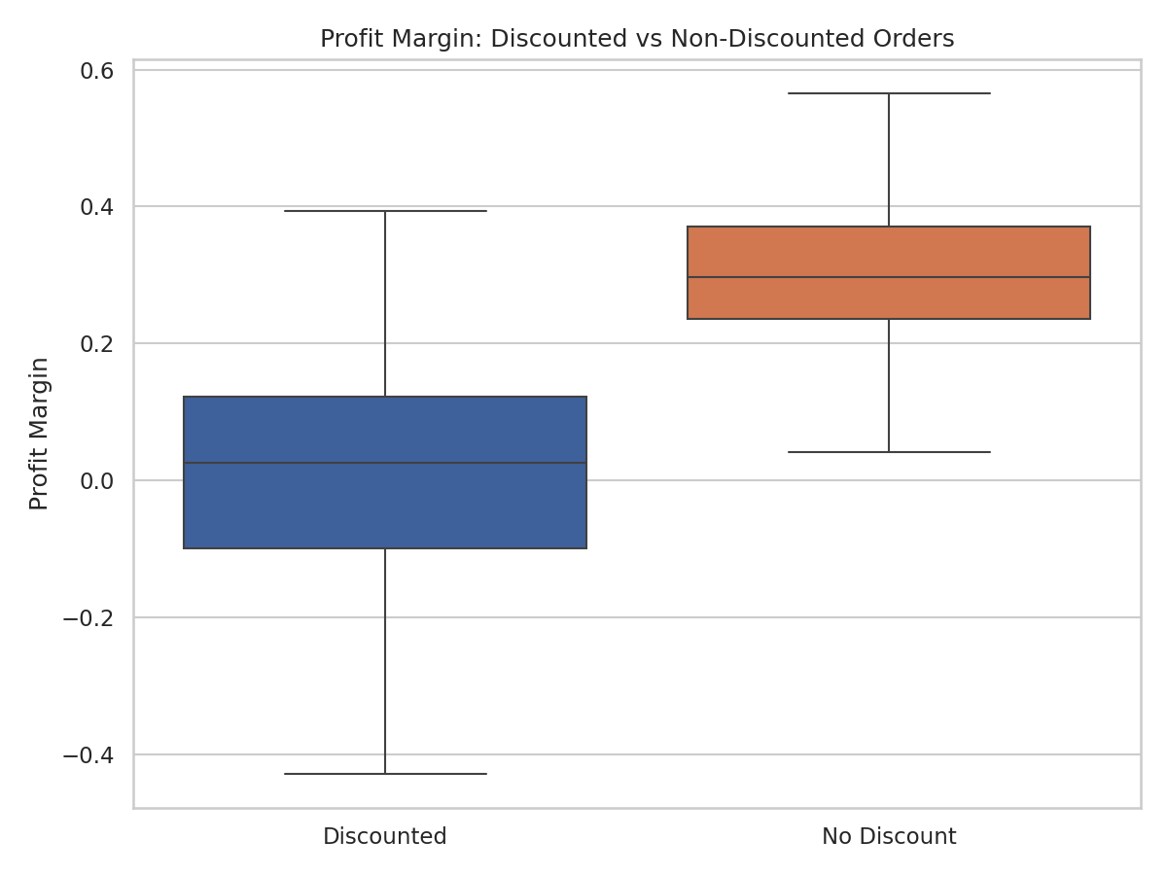
Figure 1. Profit margin for discounted vs non-discounted orders.
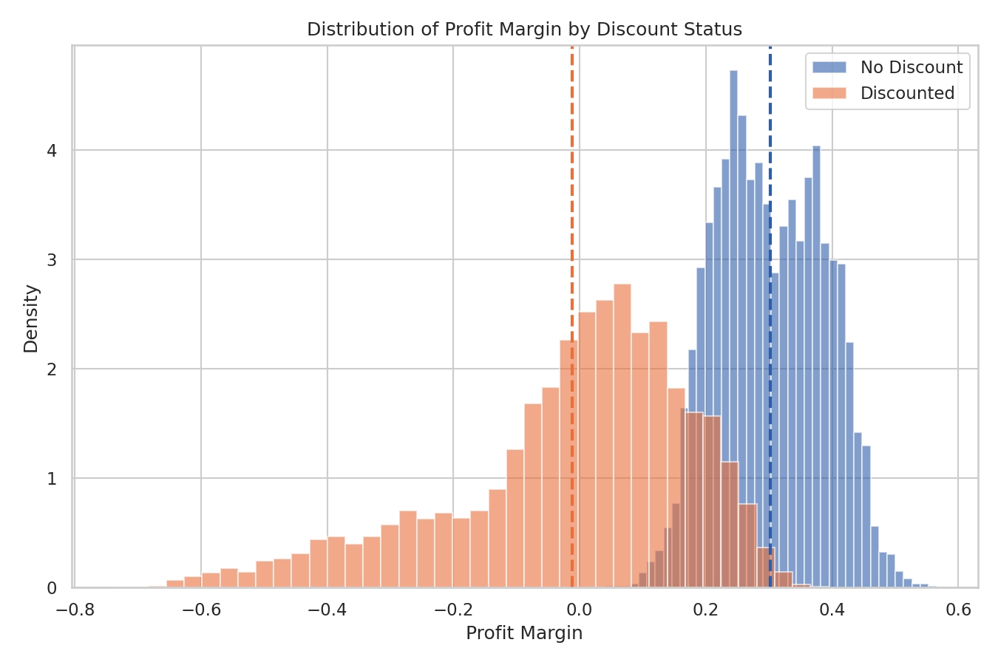
Figure 2. Overlapping distributions - dashed lines show group means.

3.4 Interpretation
p is way below 0.05, so I reject H0. Discounted orders really do have a lower average profit margin, and looking at the histogram, the discounted group's distribution stretches well into negative territory while the non-discounted group barely dips below zero. This backs up what I suspected from the Week 2 scatter plot, except now it's backed by an actual test instead of just "the line goes down." The effect size here is also just large in a practical sense, not only statistically significant - a ~31 percentage point drop in margin is a big deal for a business.

4. Test 2 – Is Product Category Related to Customer Segment?

4.1 Hypotheses
H0: Segment and Category are independent (no relationship).
H1: Segment and Category are related.

4.2 Code
contingency = pd.crosstab(df["Segment"], df["Category"])
chi2, p_chi, dof, expected = stats.chi2_contingency(contingency)

4.3 Results
Segment | Furniture | Office Supplies | Technology
Consumer | 1,134 | 1,979 | 1,476
Corporate | 694 | 1,166 | 962
Home Office | 402 | 690 | 497

χ2(4, N = 9000) = 4.90, p = 0.298. Cramer's V = 0.017 (basically zero association).
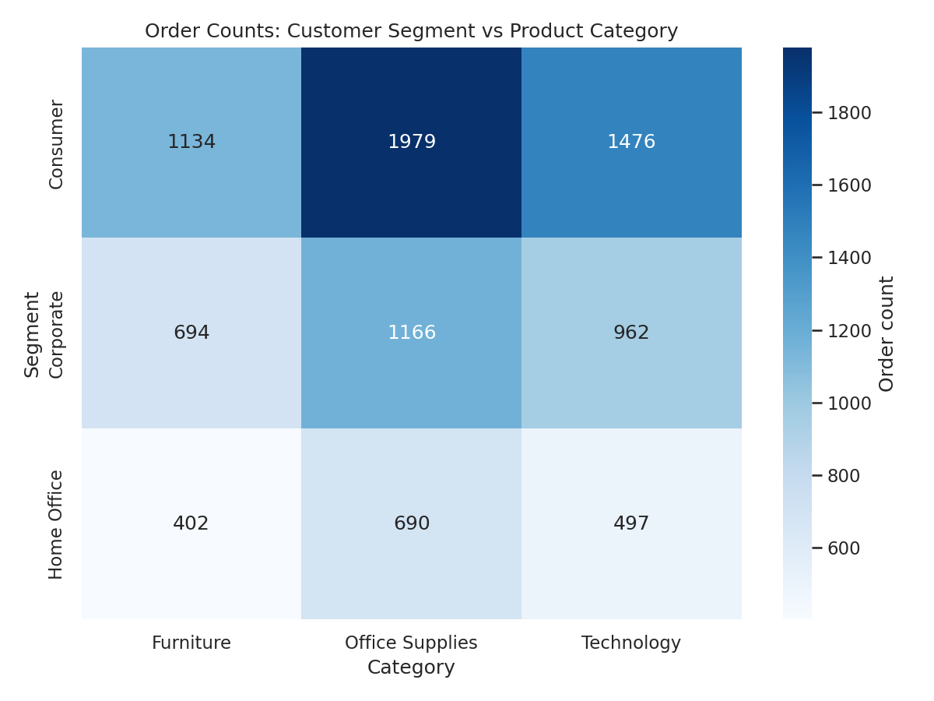
Figure 3. Order counts by segment and category.

4.4 Interpretation
p = 0.298 is well above 0.05, so this time I fail to reject H0. I honestly expected some relationship here - I assumed Corporate buyers would lean more towards Technology, for example - but the data doesn't support that. Looking at the heatmap, the proportions across categories look pretty similar for every segment, they just differ in total volume (Consumer has the most orders overall). So in this dataset, which product category someone buys doesn't depend on what type of customer they are. This is a good reminder that not every hypothesis you're curious about turns out to be true, and that's a valid, useful result too.

5. Test 3 – Does Average Order Value Differ by Region?

5.1 Hypotheses
H0: mean Sales per order is equal across all 5 regions.
H1: at least one region has a different mean Sales per order.

5.2 Code
groups = [g["Sales"].values for _, g in df.groupby("Region")]
f_stat, p_anova = stats.f_oneway(*groups)

# manual check of the ANOVA table
ss_between = sum(len(g) * (g.mean() - grand_mean)**2 for g in groups)
ss_within = sum(((g - g.mean())**2).sum() for g in groups)
ms_between = ss_between / (len(groups) - 1)
ms_within = ss_within / (len(df) - len(groups))
F = ms_between / ms_within

5.3 Results
Region | n | Mean sales | Std dev
Latin America | 1,232 | $609.53 | $687.94
Middle East & Africa | 777 | $612.33 | $721.06
North America | 2,864 | $575.16 | $627.35
Asia Pacific | 1,986 | $571.51 | $625.80
Europe | 2,141 | $570.24 | $660.62

F(4, 8995) = 1.346, p = 0.250.
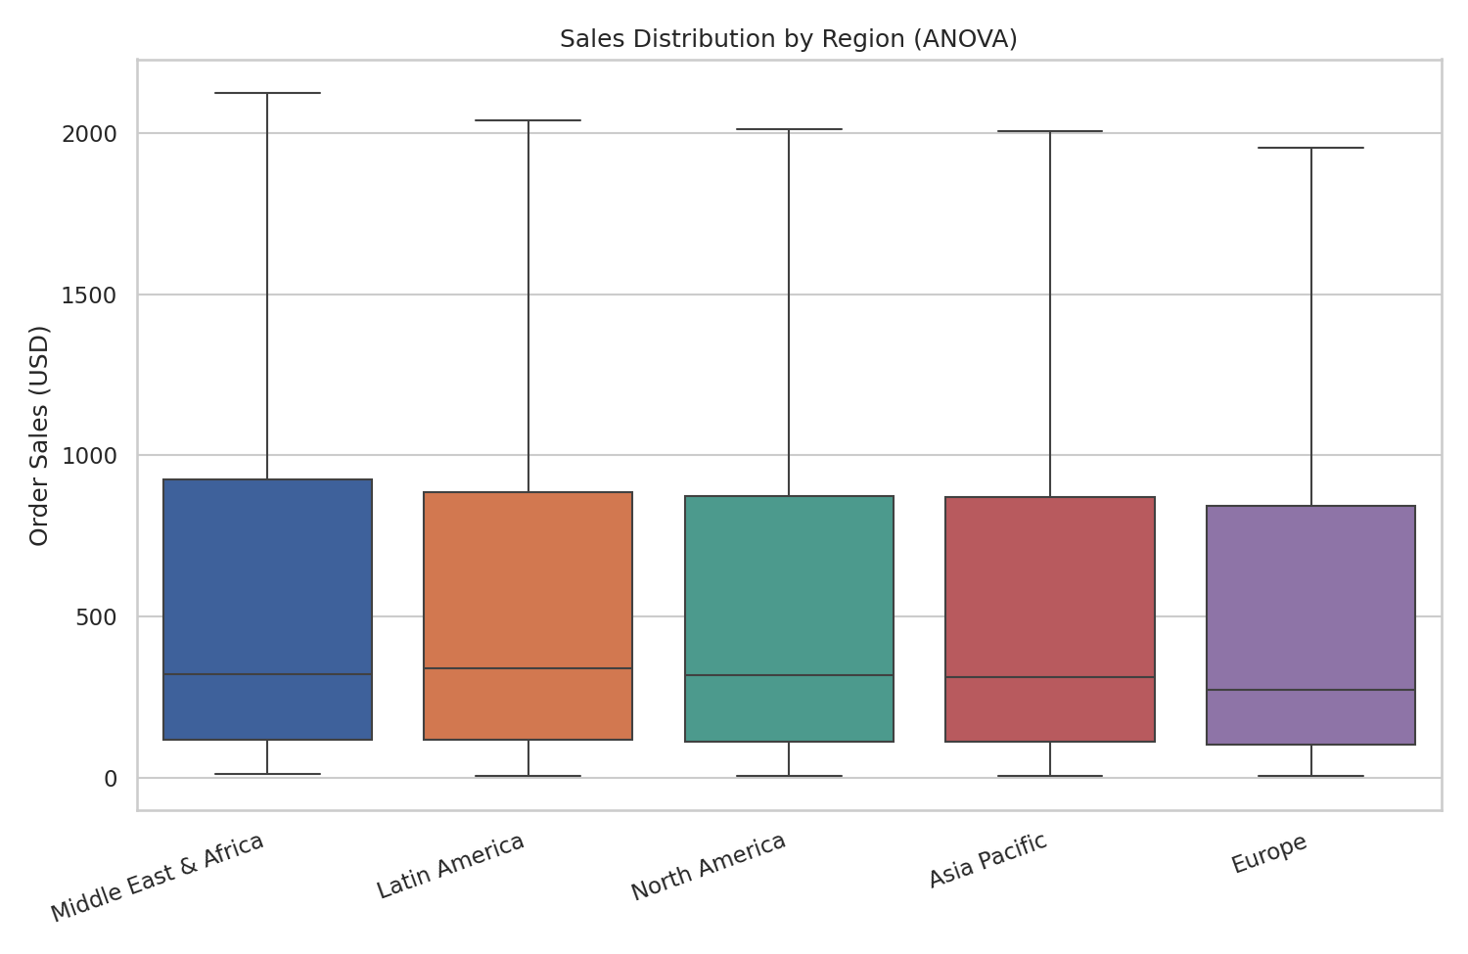
Figure 4. Sales distribution by region (outliers hidden for readability).
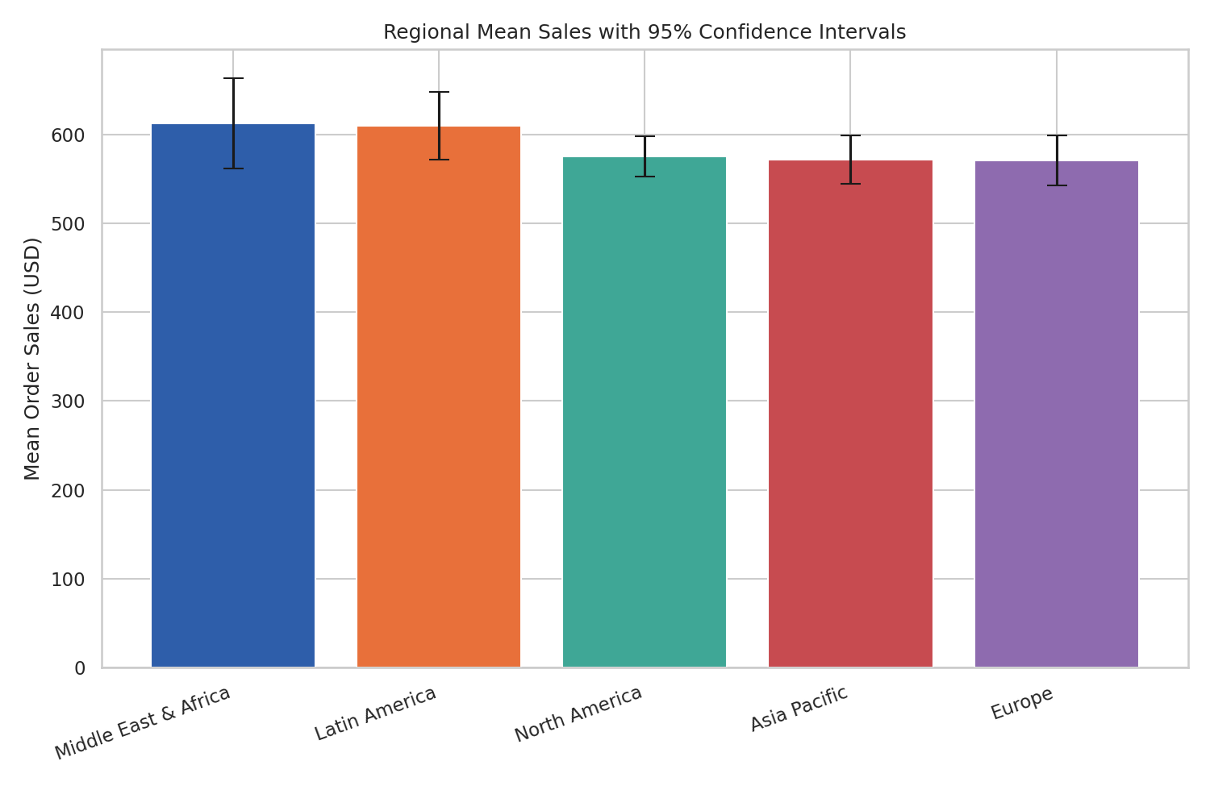
Figure 5. Regional mean order value with 95% confidence intervals - the overlapping bars visually confirm the ANOVA result.

5.4 Interpretation
p = 0.250, so I fail to reject H0 here too. This one actually surprised me at first because in my Week 2 report I found that North America had way more total sales than Middle East & Africa. But total sales and average order value are two completely different things - North America has more total sales mainly because it has more orders (2,864 vs 777), not because each individual order is bigger. In fact the confidence interval chart shows all five regions' average order values overlapping quite a bit. So the earlier finding about regional revenue differences still holds, but it's driven by order volume, not by customers in some regions spending more per order than others. I ran a quick post-hoc t-test between the two most different-looking regions (North America vs Middle East & Africa) just to sanity check, and that also came back non-significant (p = 0.191), which is consistent with the overall ANOVA result.

6. Summary of Results
Test | p-value | Result | Conclusion
T-test: Discount → Margin | < 0.001 | Reject H0 | Discounting significantly lowers profit margin
Chi-square: Segment × Category | 0.298 | Fail to reject H0 | No real relationship between segment and category
ANOVA: Sales × Region | 0.250 | Fail to reject H0 | Average order value doesn't differ by region

7. Conclusion
Out of the three hypotheses, only one turned out to be statistically significant, which I think is actually a more honest and useful outcome than if all three had "worked." The discount-profit relationship is the clear, strong finding here - it's backed by a massive t-statistic, a tight confidence interval nowhere near zero, and it lines up with what the Week 2 visualization already hinted at. That's the one I'd take to a manager: cap discounts, because they're demonstrably eating into margin.
The other two results (segment vs category, and region vs order value) were not significant, and I think that's worth reporting honestly rather than only showing the "positive" result. It tells us that, at least in this dataset, customer segment doesn't predict what people buy, and that regional revenue differences come from order volume rather than order size. Both are useful things for a business to know, even though neither hypothesis was "confirmed."
One thing I'd want to check if I did this again with real (not simulated) data: run a proper post-hoc test like Tukey's HSD instead of just one pairwise t-test for the ANOVA, and maybe check the normality assumption more carefully for the t-test since profit margin is a bit skewed. But for this dataset size (9,000 rows) the tests should be fairly robust to minor violations anyway.
End of report.

